## Solar energy calculator - Description of project work

2016-11-04

by

Bengt Stridh

Adjunct lecturer

Mälardalen University

School of business, society and engineering

Box 883, 721 23 Västerås

+46-21 32 30 67

bengt.stridh@mdh.se

### Time to meet in person

I am in Marrakech, Morocco, for an IEA PVPS Task 15 meeting on building integrated photovoltaics (PV) the coming week. I suggest we plan for a meeting on Monday 14 November after lunch, e.g. 13.00 at MDH. Please, verify that this date and time fits your schedule, if not suggest another time.

Meanwhile you can send question by e-mail, I will try to answer within one day if possible.

### Background

The Future Energy Center research specialization at Mälardalen University has in a previous project developed detailed models to analyze investment decisions for photovoltaic (PV) plants in Sweden. The task in this project is to develop a web-based tool to support different stakeholders, such as companies and private persons, to determine what investments in solar energy are suitable for them based on a number of default parameters that can be adjusted by the user. The photovoltaic market has been growing strongly during the last years. However, in general the knowledge of PV among potential investors is low. Therefore, there is a strong need for a user friendly tool to calculate production cost and profitability for PV investments in Sweden

Useful skills and knowledge: Web technologies (for example PHP, ASP, AJAX, etc.)

## Calculations

The calculations will be based on the methods used in Excel-templates from the project ”Investeringskalkyl för solceller”. The Excel templates can be downloaded on the home page of the project: <http://www.mdh.se/forskning/inriktningar/framtidens-energi/investeringskalkyl-for-solceller-1.88119>

There are two versions of the templates. One for private persons and one for others. The formulas for the calculations are the same but the default input values are different.

The calculations are based on a method called Levelized Cost of Energy (LCOE).

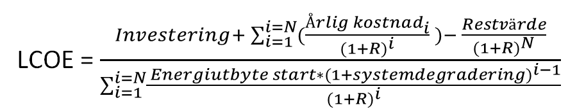

i = year, N = economic life (ekonomisk livslängd) in years in years and R = discount rate (kalkylränta). The seven parameters in formula are in turn dependent on other assumptions that have to be made.

The present values are calculated according to

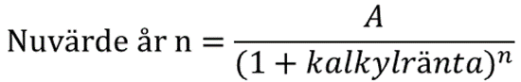

where A is the value at year n. Om exempelvis ett växelriktarbyte kostar 50 000 kr under det 15:e året efter driftstart av solcellsanläggningen och kalkylräntan är 5% blir nuvärdet 50 000/((1+0,05)^15) = 24 050 kr.

## Properties of the calculator

The purpose of the calculator is to calculate the **production cost** and **profitability** for photovoltaic installations in Sweden. These values will be a basis for investment decisions by the users.

#### Users

The majority of the PV installations in Sweden is and will be done by private persons. So private persons is a major user group. But, the calculator should also be able to be used by any user that has an interest in PV, such as companies (privately owned, construction companies, electricity companies), property owners, cities (kommuner), country councils (landsting), consultants etc.

#### User input

There are many parameters that are needed for the calculations. Many users are not familiar with PV and do not know the proper value of all parameters. Therefore, it should be possible to use default parameters, with different set of parameters for

* **Private** **persons** (that pay VAT) and
* **Others** (that do not pay VAT)

To guide the user it is important to have help texts that explain what is supposed to be input for each parameter. In the Excel sheets there is

* A column with comments that could be used as help text.
* Columns with suggested minimum and maximum values.

No input values should be locked. All input values should be possible to be changed by the user. In the Excel sheets there are some verifications done of some of the input values so that they are not unrealistic. If this is applied it has to be done with great care, since it can also cause problems for the user if certain values that are correct are not allowed, if the programmer has set to narrow limits for the input values.

It would be nice if the user could

* Save the used input values from one session to another session at a later time.
* Switch between Swedish and English language.
* Compare the calculated values for two sets of input parameters. It is not a must, but would a nice feature.

#### Output

See the Excel files for examples.

* Production cost
* Profitability
* Cash flow
* Diagrams with for example
  + Present values
  + Pie diagram with cost shares
  + Pie diagram with income shares
* Possibility to make a report file that could be printed. With input and output values.

#### Future update possibilities

The plan is to publish the web calculator on a web page at MDH or at some other host.

An important feature of a web calculator is to keep it up to date with legalizations, prices of electricity, prices of electricity certificates etc. Therefore it should be easy to update

* Guiding texts
* Default values, as well as suggested minimum and maximum values

For my point of view it would be preferable to have all these values in a file (e.g. Excel) and that an update could be done by just uploading an updated file.

## References

An important feature of a web calculator that is supposed to be used by anyone, even without having any earlier knowledge about PV, is that it should be user friendly.

There are some LCOE-calculators available, web based or Excel files. Some better that others regarding user friendliness….

**Webb**

* Elforsk [beräkningsapplikation](http://www.elforsk.se/calculator/) (Sweden)
  + Production cost only, not updated since 2014. Outdated default values. General, not specifically for PV. Not done by experts on PV.
* [Solelekonomi](http://www.solelprogrammet.se/projekteringsverktyg/berakningsverktyg/) (Sweden), Solelprogrammet
  + PV production and economy, not updated since 2010. Old and outdated. No updates done.
* [Solkollen](http://www.solkollen.nu/) (Sweden),
  + PV production and economy. Started 2016?
* [NREL Levelized Cost of Energy Calculator](http://www.nrel.gov/analysis/tech_lcoe.html) (USA)
* [Levelized Cost of Energy Calculator](http://www.energy101.com/calculators/) (USA, University of Texas)
* [PVGIS](http://re.jrc.ec.europa.eu/pvgis/apps4/pvest.php) (Europa etc.), EU-project.
  + Can be used to calculate expected yield (kWh/kW) for a PV system. The user can use this tool to get an input value for expected yield, than can be used in our calculator.

**Excel**

* [Calculator of Levelized Cost of Electricity for Photovoltaics](http://www.agora-energiewende.de/en/topics/-agothem-/Produkt/produkt/89/Calculator+of+Levelized+Cost+of+Electricity+for+Photovoltaics/) (Germany), version 1.2 from February 2014.
* Danish Energy Agency (Energistyrelsen). [Levelized Cost of Energy Calculator](http://www.ens.dk/en/policy/Global-cooperation/information-materials/general-information-policies-tools/toolkits-0)
* NREL. [Cost of Renewable Energy Spreadsheet Tool](https://financere.nrel.gov/finance/content/crest-cost-energy-models) (CREST)